TEDxSVSU

**Final Report** for Saginaw Valley State University Foundation

September 19, 2015

# Summary, Goals and Outcomes

The Resource Grant Program funded TEDxSVSU, a one-day event that took place Saturday, August 1, 2015. Student volunteers, local and national speakers, exhibitors and musical artists contributed to the production.

Goal: Student leadership experience. Outcome: The event developed students’ real-world conference management experience. Students made direct contact with recognized innovators. Students directly contributed to increasing worldwide awareness of SVSU, enhancing the reputation of the institution from which they are receiving degrees. For a list of the student leaders, visit: <http://www.ted.com/tedx/events/15596>. Other student participants: Aaron Hooper, Andrea McGhee, Andrew Robishaw, Bradley Chippi, Amanda Cobb, Brian Cobb, Brittany Lentz, Brooke Meade, Callie Youngman, Imran Khan, Joshua Gillard, Kevin Deary, Kylie Wojciechowski, Matt Walker, Ryan Moormann, Scott Ellis (alum), Shafayat Alam, Shahamatul Alam, Sophie Butcher, Stephen Cecchini, Yan Huang.

Goal: Faculty interaction with students outside of the classroom. Outcome: A dozen faculty and staff contributed formally and informally, including Ann Garcia, Blake Johnson, Chad Dewey, Dan Goodell, Dustin Spencer, George Corser, Jason Swackhamer, Kim Lacey, Mike Major, Neil Baumgartner, Poonam Kumar, Ted Lind.

Goal: International audience for SVSU. Outcome: The event generated ten videos published to [www.ted.com](http://www.ted.com).

Goal: Local audience, increase breadth and depth of understanding of SVSU. Outcome: Generally positive. Some direct quotes from the TED.com audience feedback forms.

* Great event full of interesting speakers. Provided lunch and coffee were both very appreciated.
* I initially came to this event as my daughter's guest. I was surprised how much I actually enjoyed it. As this was SVSU's first go round, I would definitely give it another try and I would tell others about it.
* TQE-total quality experience
* I thought that everything was well put together. I think with a little more publicity this could be a very good thing for SVSU. I also enjoyed the speakers and I am glad I got to show case SVSU in this way to my family (who had never been to the university and who were all pleasantly surprised about what our school has to offer!)

# External organizations

Larry Daly and Barbara Hoffman of Covenant bought T-shirts for the volunteers. Matt Macomber from the State of Michigan and Steve King from Kochville Township also assisted before and during the event.

# Future Plans

A registered student organization (RSO) has been established and plans are under way for TEDxSVSU 2016.

# Budget vs. Actual Financial Performance (Unaudited)

The project raised $2175 and expended $4756, a net loss of $2581.

A meaningful comparison of budget versus actual is difficult to prepare. The initial plan was that revenues from sponsors and ticket sales would offset expenditures. But it took us longer than anticipated to develop contacts willing to provide financial support. Further, the line items did not match up with actual results. For example, post production required zero funds while speaker and volunteer food was double the cost originally planned. The fact that expenses could not be precisely estimated was known at the outset and was reflected in the several asterisks in the original budget. The original budget from the proposal is as follows.

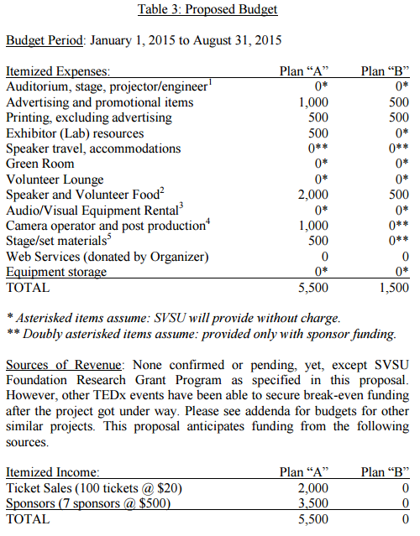

The actual results are below.

Submitted sincerely and respectfully,

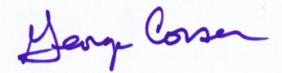

George Corser, Assistant Professor, CSIS

Revenues and expenditures spanned two fiscal years. The data below are from Cardinal Direct.

## Fiscal Year 2015: Revenues

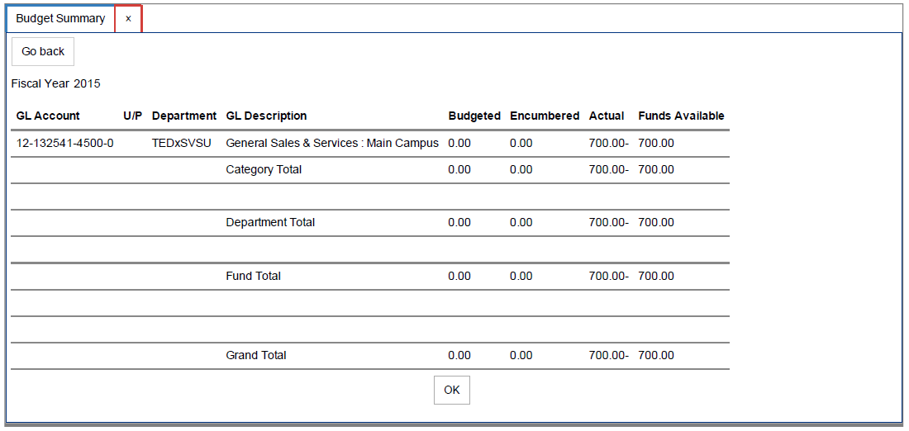

## Fiscal Year 2015: Expenditures

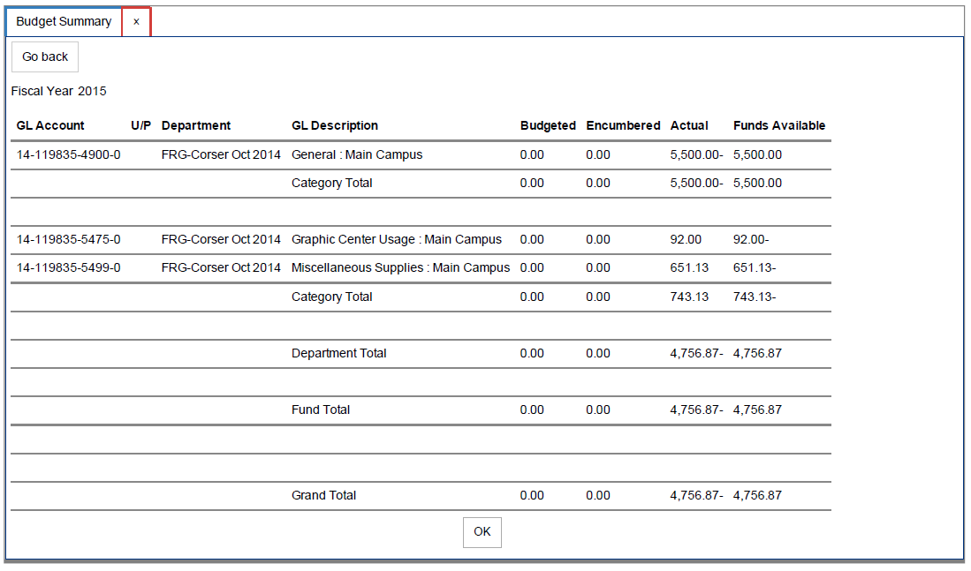

## Fiscal Year 2016: Revenues

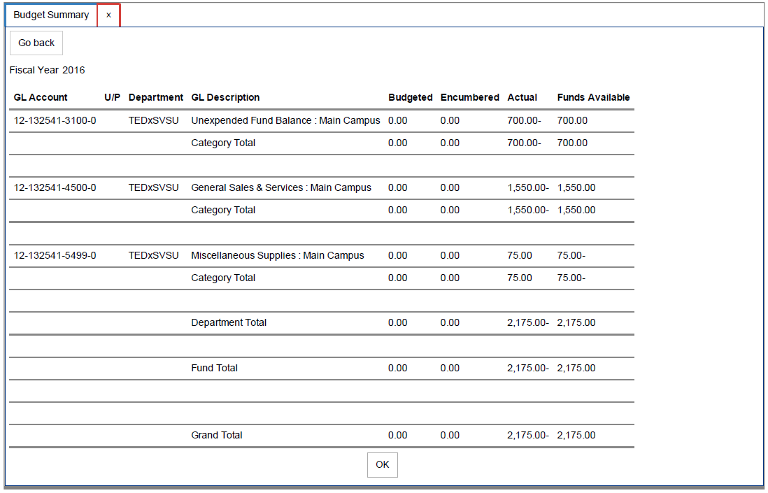

## Fiscal Year 2016: Expenditures

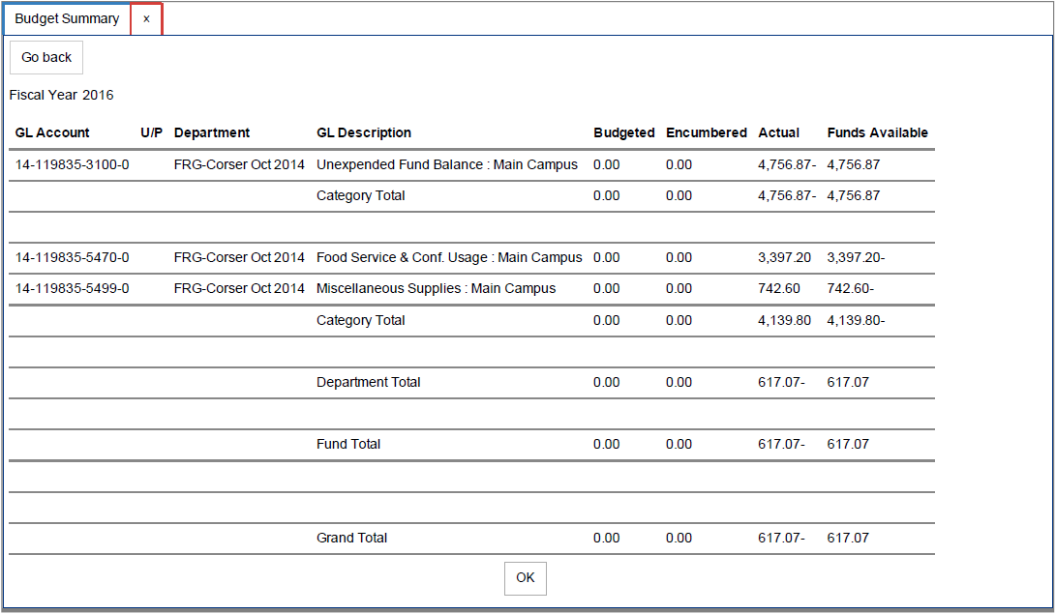

# Two samples of materials from the project

Flickr photo page and TED webpage

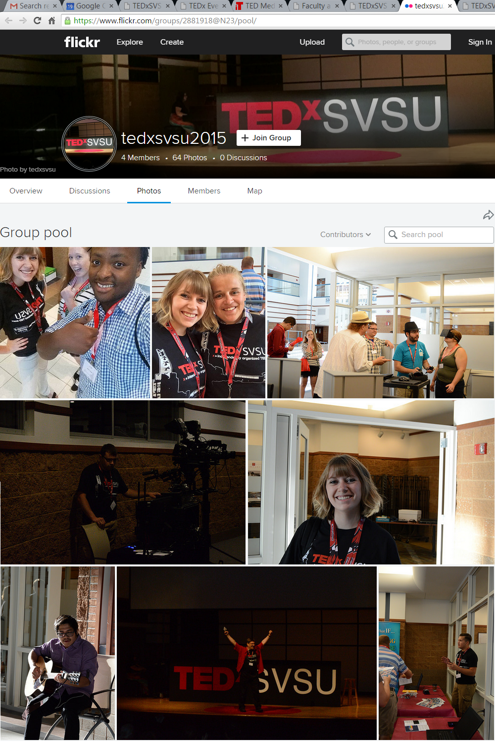

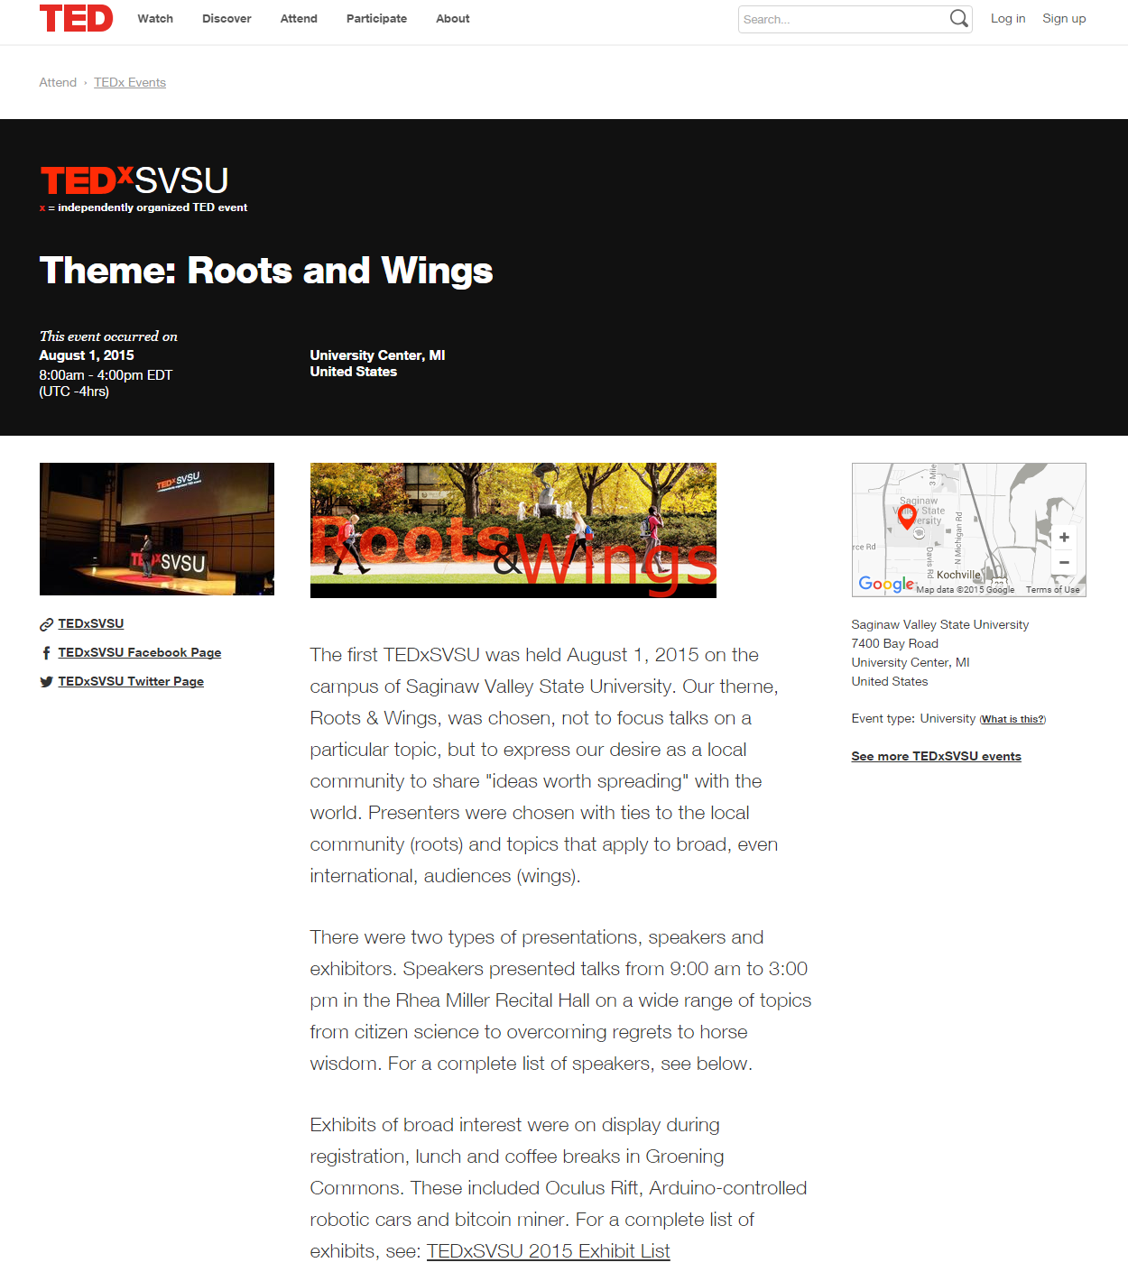

# Articles from local media

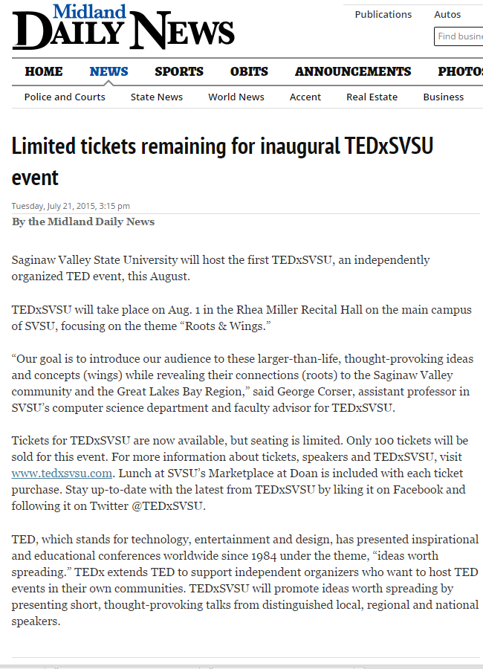

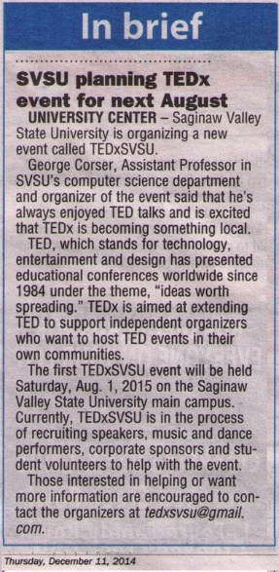

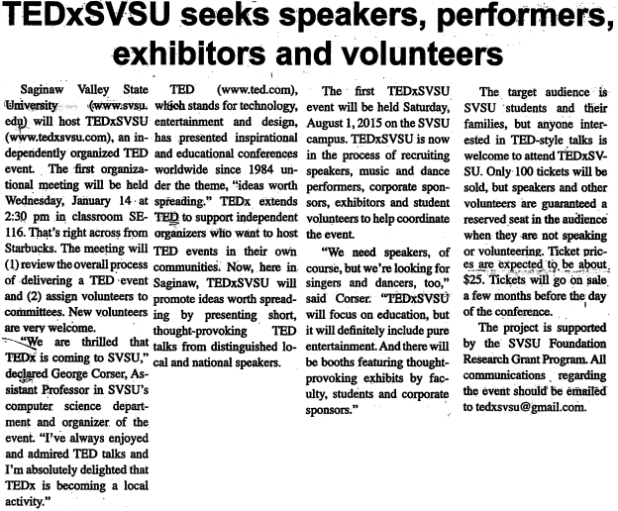

# Materials acknowledging the SVSU Foundation Grant Program

